Renju lesson on April 25, 2002

Hello everyone! Welcome to Online Renju Class. Today we need to focus on the last choice of the 4th move, that is 4-j7. After we finish 4-j7 and 4-h7, we can end the study of i3 opening? Likely, we need to select the new opening for the next week. Therefore, please think about the choices, and in the end of the class we will choose one together. Deal?
Which are the 5th moves here?
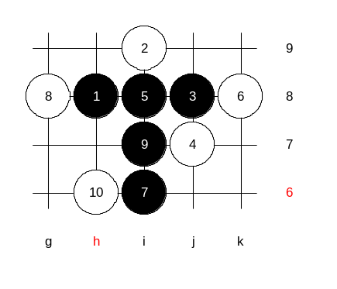
Indeed, 5-i7 and 5-h9 are the best ones. Move 5-i8 used to be popular in Russia 10 years ago, but black has lots of troubles there in case of white's good defense. In case of 5-i8, white can successfully block the three from either end.

By the 10th move black attack is complicated.

If 9-h6 then 10-i7.

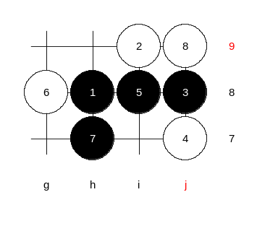

This 8th move is the troublemaker in this variant. Black has no good continuation.

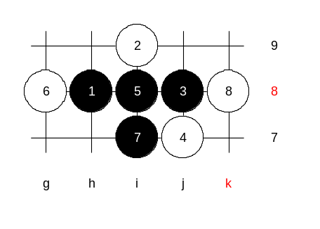

This 7th move is quite strong. Typical 8th move 8-h6 leads to black win after very complicated attack. However, peculiar 8th move 8-k8 holds the position well.

Therefore, I do not recommend to use 5-i8 as long as black win is questionable there.

How many of you know black win after 5-i7? Ok, lets show some example wins here.

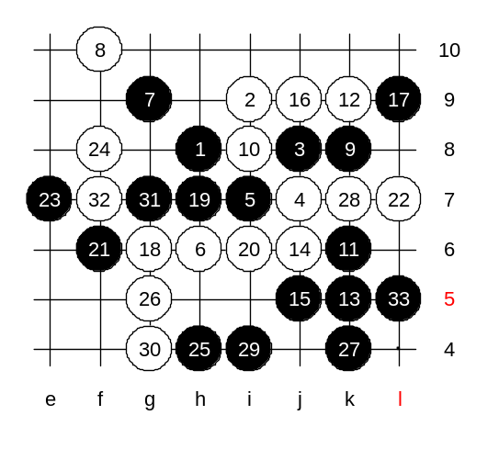
Typical 6th move 6-h6 will be our first target. Who knows black win after such 12th move? The win here is not so obvious as you may think? It used to be an object of the big dispute before. Old books had either ignored this move or offered wrong solutions. The only solution I could finally come up with, is this: The idea of 13th and 15th move is good. The first 22 moves are practically forced. The last step - connecting forces. Move 29-i4 is a key move. The logical 29-j4 caused some problems in my analysis. By the 33rd move the win is clear.

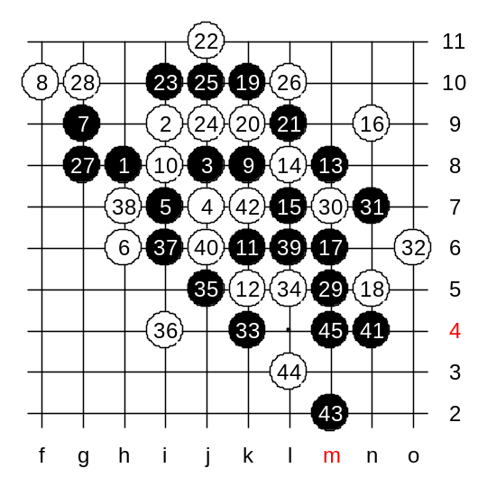

I think we can now check the next 12th move.
The 12-k5 goes by the book. beautiful 27th move will prepare the supporting stone for lower side attack.

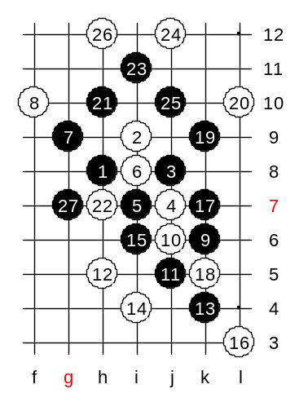

We check one more 6th move before we change the 5th.
Until 14th move - both sides play optimal moves. Move 17-k7 - the simplest way.

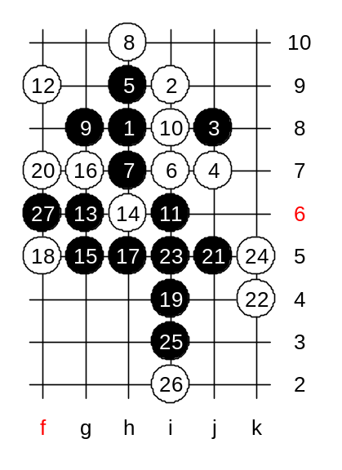
This is the alternative 5th move. How many of you know the black win here? By the book, it is sure win. which 6th move comes first?

This is the first win.

Next 6th move? OK, 6-h7 now.
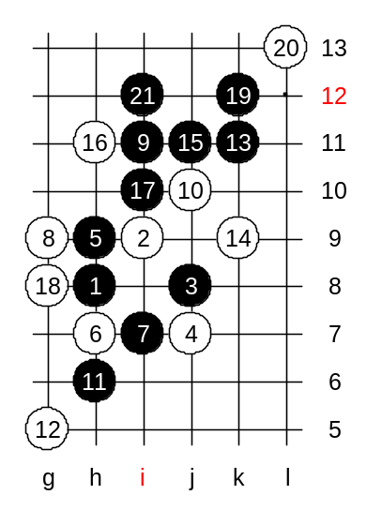
The 8-g9 is the strongest. My words in book: "This position was a big question for me for years. I could not find any good attacking idea and direction because of even distribution of black and white stones. Finally I found the winning 9th move."
9-i11!
This is the best finding of mine under this 6th move. The following is: The main variant that is shown in the book includes the optimal moves for both sides. All the side variants are shown in comments beside the diagram. The timing of each move is extremely important!!
If 10-g8, or 10-h11, or 10-j11 then black vct with 11-k9, 12-L10, 13-L8.

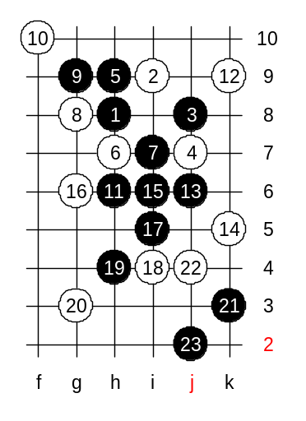

This 8th move is too weak.

We have checked the moves important defenses with this 4th move. It is time to end with this nice opening. We do not have time to check 4-h7, but I am sure most of you can try it at home and see if there are any differences from 4-j7.
Now, lets say bye to i3 and select the new opening. Ok, thank you, so we choose i9 to be our next opening. The lesson is over now, thank you all for coming. I am looking forward to see you here again next Thursday, learning i9 opening. The credit results follow now.

